Finding books and eBooks for English Literature, Creative Writing and Drama

1. How do I search for books & eBooks?
Use LibrarySearch on the Library home page at http://www.brookes.ac.uk/library/
Type in the type in the author, title or subject that you are interested in and click Search.
Here is a search for the book Technology, Literature and Culture by Alex Goody. There’s no need to type in all these details; the author surname and a few words from the title should be enough:
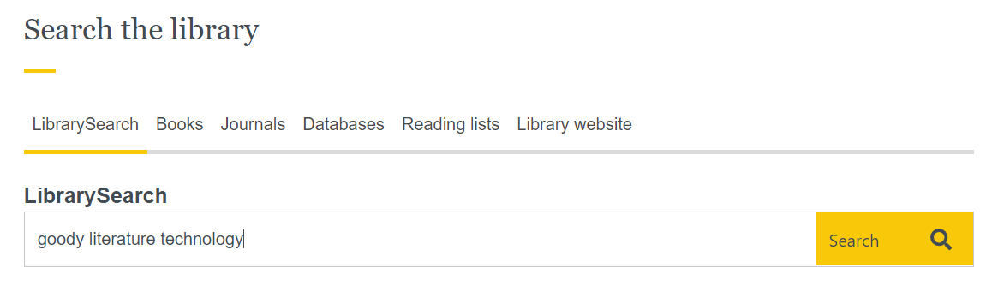
Books will usually come up at the top of your search results, but you will also find articles and other resources. To see only the book results, scroll down the Search Tools box on the left of the screen. To see only the book results, scroll down the filters on the left of the screen. Look for the Format option and tick the box next to Book.
Click on the blue title link to find out more about a specific book
1
5
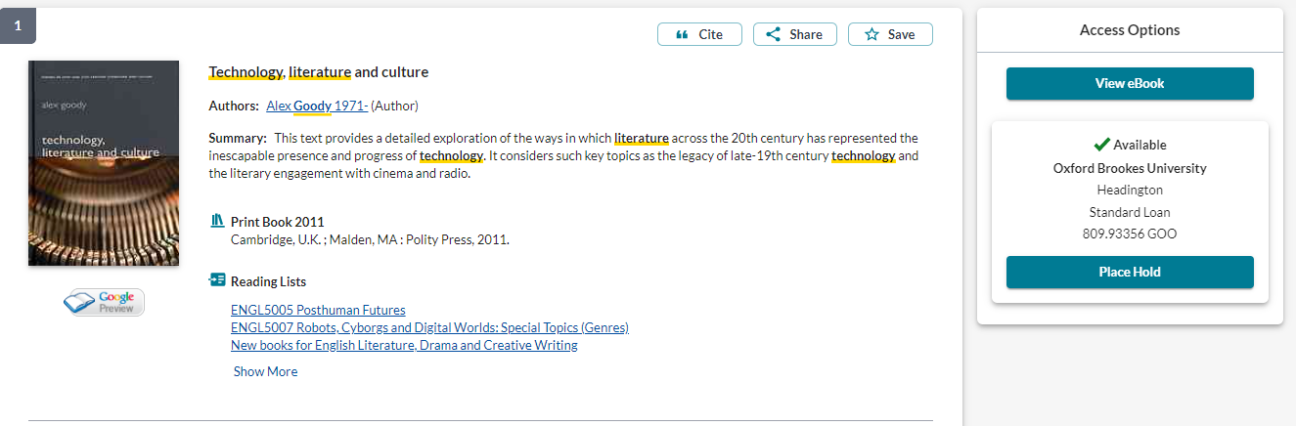
2
3
4
- View eBook: Connect to the eBook (Brookes student number & password required).
- 809.93356 GOO: Print books have a call number which this tells you where the book is shelved in the Library.
- Place Hold: If the book is on loan to another user or at one of our other libraries, you can put a hold on it. If it's on the shelves, it's quicker for you to go and get it yourself.
- Reading lists: View reading lists that recommend this book
- Cite and Save options: You can copy the citation but always check Cite Them Right Online before putting it in your written work. Find out more from 3 tips for improving your referencing – and your marks! at https://www.brookes.ac.uk/library/resources-and-services/course-resource-help/english-literature-and-creative-writing/reference-with-mhra

2. How do I borrow books?
- Use the self-service machines to borrow books (you'll need your student card).
- Undergraduates may borrow up to 20 books (Postgraduates, staff and researchers may borrow up to 30) for 1 week.
- Most items will be automatically renewed on the date they are due to be returned. Loans that have been reserved by someone else will not be automatically renewed and must be returned.
NB Check your Brookes emails to keep track of your loans and renewals. We will only contact you if you need to do something.
- Find out more from our guide How to Borrow and return books: https://www.brookes.ac.uk/library/how-to/borrow-and-return-items

3. If I want to browse the Library shelves, where should I go?
In the Headington (JHB) Library, the main sections for English Literature, Drama and Creative Writing are on Level 4. Books on a similar subject will be shelved together, making it easier for you to browse. Here are some useful sections of the Library:

Literary studies |  | Creative writing
801 | Literary theory | 808.02 | Creative writing
808 | Anthologies | 808.06692 | Writing biography
809 | History and criticism of literature | 808.1 | Writing poetry
810 | American literature: general | 808.2 | Writing drama
811 | American poetry | 808.3 | Writing fiction
812 | American drama | Theatre
813 | American fiction | 791 | Performing Arts
820 | English literature: general | 791.43 | Film
821 | English poetry | 791.437 | Film adaptations
822 | English drama | 792 | Theatre
822.33 | Shakespeare’s plays | 792.0233 | Theatre directing
823 | English fiction | 792.025 | Theatre design, scenography
832 | German drama, e.g. Brecht | 792.026 | Costume & make-up
839.8226 | Norwegian drama, e.g. Ibsen | 792.028 | Acting
891.723 | Russian drama, e.g. Chekhov | 792.0941 | British theatre

In the literature section, each number is further divided by time period e.g.
Elizabethan and Jacobean drama 822.3 Contemporary drama 822.92
Victorian fiction 823.8 Modern fiction 823.92

Individual authors, such as Dickens, have their own works followed by critical works and biographies e.g.
823.8 DIC for Dickens - Great Expectations
823.8 DIC/P for Lyn Pykett’s Charles Dickens: critical issues

At Headington we have an extensive collection of books by and about Shakespeare, so these are arranged in a particular way:
- The Shakespeare section is at 822.33
- The call number for individual Shakespeare plays include the beginning of the play title in brackets, e.g. Titus Andronicus 822.33 SHA (TIT) The Winter’s Tale 822.33 SHA (WIN)
- The call number for biographies and critical works about Shakespeare’s plays includes part of the author’s name, e.g. Titus Andronicus: critical essays, by Philip C Kolin 822.33 KOL
Will in the world: how Shakespeare became Shakespeare, by Stephen Greenblatt 822.33 GRE
- The Shakespeare Survey series publishes annual collections of essays on specific topics. You can browse a list of the annual editions on the Cambridge University Press website. The books are shelved at 822.33 SUR. NB We don’t have online access to this series.

Open access special collections

- Oxford Brookes Poetry Centre Collection – Level 4. A collection of contemporary poetry books from the UK and beyond. All the books can be borrowed. You can find out more about this collection online at: https://www.brookes.ac.uk/library/resources-and-services/course-resource-help/english-literature-and-creative-writing#poetrycollection
- Booker Prize shortlisted titles (reference only) – Level 4
- Africa Publishing Collection – Level 2, Mobile Shelving.

4. Further help for English Literature, Creative Writing and Drama
- If you would like further help, please contact the Academic Liaison Librarian for English Literature, Joanna Cooksey by emailing jcooksey@brookes.ac.uk
- Check the Course resource help for English Literature and Creative Writing at: https://www.brookes.ac.uk/library/resources-and-services/course-resource-help/english-literature-and-creative-writing for links to key-e-resources, guides and much more.

[JC englishbooks 08/2021]

