A guide to finding books and eBooks in Brookes Library

1. How do I find books in the Library?
Brookes Library uses the Dewey Decimal Classification system to arrange the book stock. Every item is assigned a call number (also known as a shelfmark) between 000 – 999 which indicates its subject and enables you to locate it on the library shelves. Books on a similar subject will be shelved together, making it easier for you to browse.

Follow these steps to find a print book in the Library:

Step 1: Search for the book using LibrarySearch
Go to the Library home page at http://www.brookes.ac.uk/library/ and in the LibrarySearch box type in the author, title or subject that you are interested in and click Search.

Here is a search for the book Academic Writing: A Handbook for International Students, by Stephen Bailey. There’s no need to type in all these details; the author surname and a few words from the title should be enough:
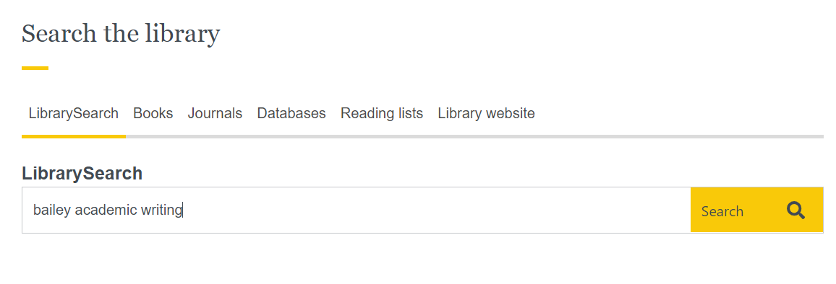
At the results screen we can see this book: Books will usually come up at the top of your search results, but you will also find articles and other resources. To see only the book results, scroll down the filters on the left of the screen. Look for the Format option and tick the box next to Book.

Click on the blue title link to find out more about a specific book.
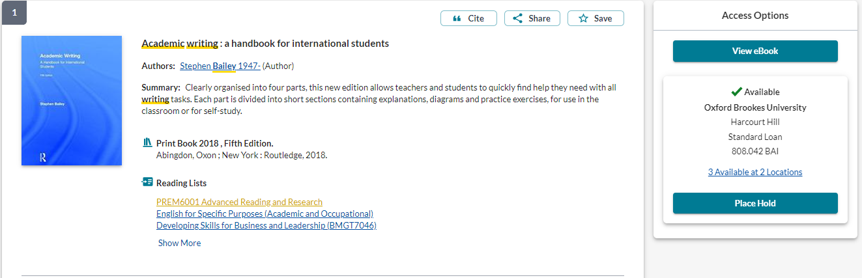
1
2
3
4
5

- View eBook: Connect to the eBook (Brookes student number & password required).
- 808.042 BAI: This is the Call Number - the code you need in order to find the book on the library shelves. The call number is made up of letters and numbers:
The numbers indicate the subject. Books on academic writing are at 808.042
The letters usually refer to the author – BAI for Bailey
See pages 3-4 of this guide for how to use the call number to find a book on the Library shelves.
- Place Hold: If the book is on loan to another user or at one of our other libraries, you can put a hold on it. If it's on the shelves, it's quicker for you to go and get it yourself.
- Reading lists: View reading lists that recommend this book.
- Cite and Save options: You can copy the citation but always check Cite Them Right Online before putting it in your written work. Find out more from 3 tips for improving your referencing – and your marks! at https://www.brookes.ac.uk/library/resources-and-services/course-resource-help/pathways-programmes#referencing

Step 2: Find out which section of the Library you need to go to.
Call numbers in the Headington Library start at 0… on Level 2 and end at 9… on Level 4.
Call numbers (shelfmarks) in the Headington Library
Level | Call numbers | Subjects
Level 2 | 000s | Computing & publishing
Level 2 | 100s | Philosophy & psychology
Level 2 | 200s | Religion
Level 2 | 300s | Social sciences  Includes sociology, anthropology, politics, economics, tourism, law, health care services, criminology, education.
Level 2 | 400s | Languages
Level 3 | 500s | Natural sciences  Includes maths, chemistry, biology
Level 3 | 600s | Technology  Includes medicine and health care, business, food science and nutrition, hospitality, construction.
Level 3 | 700s to 719s | Fine Art and planning
Level 4 | 720s | The rest of the arts subjects and recreation  Includes architecture, painting, music, cinema, sport and leisure.
Level 4 | 800s | Literature & writing
Level 4 | 900s | Geography & history

Looking at this list of call numbers, we can see that books with a call number starting 8… are shelved on Level 4.
You can pick up a copy of the Headington Library floor plan leaflet from the Help Zone on Level 1 of the Library and there are also maps on the landing of each floor. These show us that when we get to Level 4 of the library, we should go to Zone D to find the book with the call number 808.042 BAI
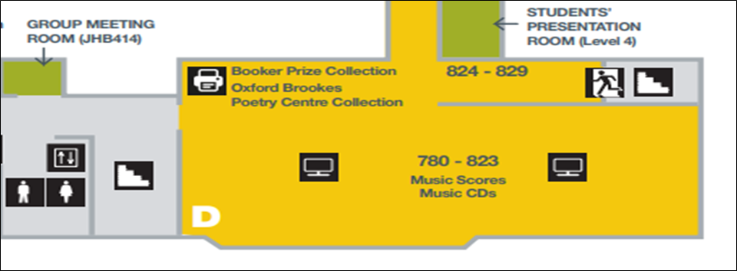
These are the call numbers of the books in this room. We are looking for call number 808.042
This room is Zone D on Level 4 of the Library

Look along the library shelves to find the book
(1) Look at the signs on the side of each shelving unit to see which call numbers are shelved there.
In our example, you’d need to go to Zone D on Level 4 and walk along looking at the signs at the ends of the shelves to find the section which covers the call number 808.042 BAI
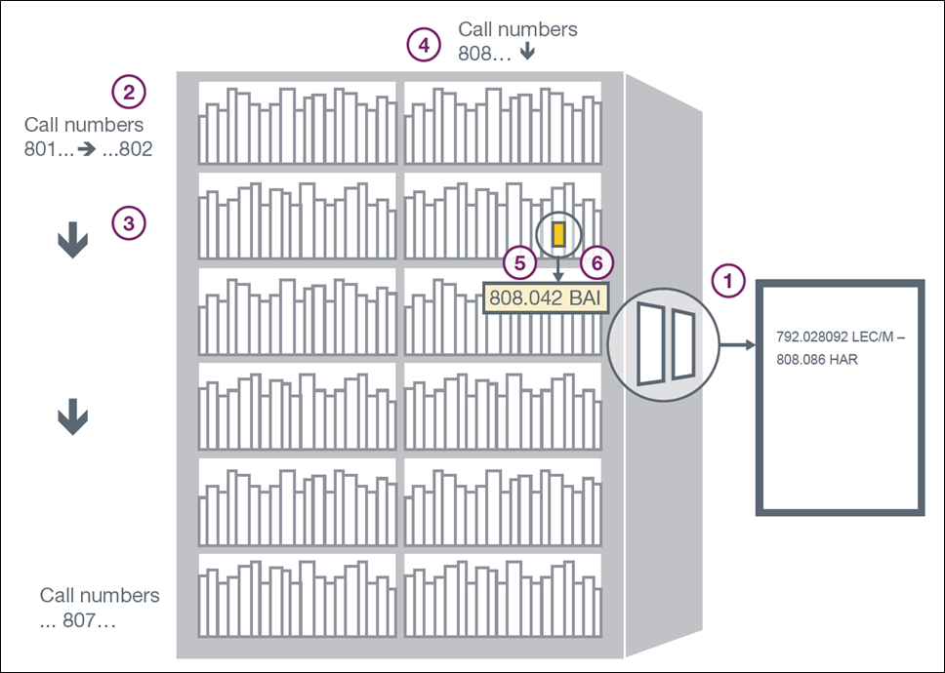
(2) When you have found the right section, scan the shelves to find your book. The call number is usually displayed on the spine of the item.
It’s easiest to start by looking along the shelves for the first three numbers (the ones before the decimal point), for e.g. 808.042
Begin at the left of the top shelf. Read the call numbers of the books from left to right ➔ until the shelf ends.
(3) Then go to the next shelf below. Again, read the call numbers of the books from left to right until the shelf ends. Carry on 1 shelf at a time, reading left to right, top to bottom.
(4) Once you reach the bottom shelf of a column of shelves (known as a ‘bay’), go to the top shelf of the next bay to the right and repeat looking left to right, top to bottom, until you find the section with the call number you need, for e.g. 808.
(5) Next look for any numbers after the decimal point, digit by digit - e.g.808.042. Scan the shelves from left to right, top to bottom as before.

(6) Finally use the letters to help you find the specific book. These are taken from the author’s surname (or the first word of the title if it’s an edited book), for e.g. 808.042 BAI.

2. How do I borrow books?
- Use the self-service machines to borrow books (you'll need your student card).
- Students may borrow up to 20 books for a week at a time. During the summer, loan periods are extended to 1 month.
- Most items will be automatically renewed for a further week on the date they are due to be returned. As long as no-one else puts a hold on the book, it can automatically be renewed up to 25 times.
- If someone places a hold on a book you have borrowed, your loan will not be automatically renewed and must be returned. The Library will email your Brookes Gmail account to tell you that a book is needed by another library user.
- NB Check your Brookes emails to keep track of your loans and renewals. We will only contact you if you need to do something.
- You do not have to pay to borrow items from the Library. However, fines are charged if you bring back an item late.
- Return your books at Headington Library through the automatic return slots next to the Welcome Desk on Level 1. You don’t need your student card.
- You don’t have to return an item to the library from which it was borrowed – you can return it to any Brookes library.
- Find out more from our guide How to Borrow and return books: https://www.brookes.ac.uk/library/how-to/borrow-and-return-items

3. What should I do if I can’t find the book?
- Can’t find it on the shelf? If you have checked LibrarySearch and it says a book is ‘Available’ but you can’t find it on the shelves, check with Library staff.
- Book is ‘checked out’ or at another Brookes Library? You can place a hold to request it. You’ll get an email notification to your Brookes Gmail account letting you know when the book is ready for collection. It can be collected from the section near the Library Welcome Desk on Level 1.
NB You should not put a hold on a book if it’s listed as on the library shelves at your home site. It is much quicker to collect it yourself from the library shelves. Ask Library staff if you can’t find it.
- Is there an eBook? Check LibrarySearch to see if there’s an eBook. You can access these from anywhere with your Brookes login details.

[JC pathwaysbooks 08/2021]

