Participative Process Review
Supplement | Problem solving supplement | Ver: 19 Oct 2015

The fishbone technique

The fishbone diagram was proposed by Professor Ishikawa of Tokyo University.

A useful approach to problem solving where there could be a multiple number of causes.

The example is a response to a problem where sometimes diners complain that their meals arrive cold at the table.

Using the fishbone technique, the problem is placed at the head of the fish.

This is followed by asking the question why?

Each time a cause was found, it was entered as a bone of the fish.

This may produce multiple set of high level definition causes.

For each bone of the fish again the question is asked why?

The second level causes are entered as branches off each bone.

Source: Francis, D (1990) Effective Problem Solving (Self-Development for Managers): Routledge

Six Thinking Hats

The Greeks (Socrates, Plato and Aristotle) promoted argument as a way of thinking with each side making a 'case' and then seeking to defend that case and prove the other 'case' to be wrong. This approach used over the centuries often creates polarisation and brings in a variety of emotions and behaviours such as competition and assertiveness.

This tool was created by Edward de Bono in his book “6 thinking Hats (1965)” proposing parallel thinking and is a technique for looking at the effects of a decision from several different points of view.

It is practical, quick and simple to use tool when trying to make a decision often related to analysing a problem.

It allows necessary emotion and scepticism to be brought into what can otherwise be often purely rational decisions. It opens up the opportunity for creativity within decision making.
Each 'Thinking Hat' is a different style of thinking. These are briefly explained on the following page:

For the method to work, it is essential that at any moment everyone is looking 'in parallel' in the same direction. There are six imaginary thinking hats. Only one is used at a time. When the hat is used everyone in the group wears (metaphorically) the same hat.

A single hat may be used on its own in a meeting or discussion to request a particular type of thinking for a defined time. Alternatively a sequence of hats are used one after the other.

Source: de Bono, E (2009) Six thinking hats: Penguin: London

White Hat | Focus on the data available. Look at the information you have, and see what you can learn from it.  Look for gaps in your knowledge, and either try to fill them or take account of them. This is where you analyse past trends, and try to extrapolate from historical data.  Example prompt questions  - What do we know?  - What do we need to know? What is missing?  - What questions should we ask?  - How might we get the information we need?
Red Hat | Look at problems using intuition, gut reaction, and emotion.  Also try to think how other people will react emotionally. Try to understand the responses of people who do not fully know your reasoning.  Examples could be  - My feeling is that this simply will not work.  - My gut feeling is that this is highly dangerous  - My intuition is that she is the right person for the assignment..  - My intuition is that the costs on this project will escalate rapidly.  - My intuition is that there are internal office politics behind that decision.  - My intuition is that the economy will start to turn up in the next quarter  An important point is that you do not have to give any reasons at all for your 'feelings'. You just express your feelings. They exist in you – so you express them. In many cases the reasons behind the feelings are not clearly known (as in intuition) and therefore people are often reluctant to put forward their feelings if they are unable to give a reason.
Black Hat | Is a hat for caution and based on critical thinking  It can be used to  - to indicate a fault in logic (that does not follow),  - to point out incorrect information  - to point out faults and weaknesses  - to point out why something does not fit  - to point out the 'downside'  - to point out potential problems  You look at the decision cautiously and defensively. Try to see why it might not work. This is important because it highlights the weak points in a plan. It allows you to eliminate them, alter them, or prepare contingency plans to counter them.  Black Hat thinking helps to make your plans 'tougher' and more resilient. It can also help you to spot fatal flaws and risks before you embark on a course of action. Of special relevance to optimists who get so used to thinking positively that often they cannot see problems in advance. This leaves them under-prepared for difficulties.
Yellow Hat | Helps you to think positively. It is the optimistic viewpoint that helps you to see all the benefits of the decision and the value in it.  This is very different from argument, where you make no effort at all to find value in an idea you do not like. Under the yellow hat every thinker is 'challenged' to find value.
Green Hat | This stands for creativity. This is where you can develop creative solutions to a problem. It is a freewheeling way of thinking, in which there is little criticism of ideas.  Use lateral thinking techniques to break out of this patterned way of thinking, such as “Brainstorming”, or “Provocation” which involves making deliberately stupid statements, in which something we take for granted about the situation is not true. Statements need to be stupid to shock our minds out of existing ways of thinking. Once we have made a provocative statement, we then suspend judgment and use that statement to generate ideas.
Blue Hat | This stands for process control. This is the hat worn by people chairing meetings. When running into difficulties because ideas are running dry, they may direct activity into Green Hat thinking. When contingency plans are needed, they will ask for Black Hat thinking, etc.

Force field analysis

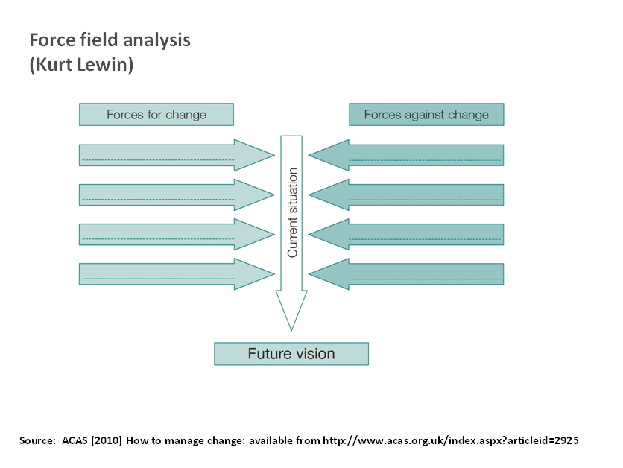

Kurt Lewin (1951) was responsible for introducing force field analysis, which examines the driving and resisting forces in any change situation. The underlying principle is that driving forces must outweigh resisting forces in any situation if change is to happen.

This can be created in a visual way of representing the forces that may hinder or support a change activity.

Choose a change you are to undergo or implement, but that you know will be difficult.
Draw a line down the middle of a piece of paper. Write the headings “Driving Forces” and “Resisting Forces” at the top of the columns. Then list the things that will help or hinder what you are trying to do. The more precise you are the better. Write the things in a well spaced list in the appropriate column

For each driving or resisting force draw an arrow pointing towards the central line. Use different thicknesses to indicate the strength of the force: the thicker the arrow, the greater the force.

Now look down the arrows on the “Resisting Forces” side. What can you do to reduce or weaken them? Write down the changes you would like to make.

Turning to a work related situation is it to do with changing people’s attitudes, or changing organisational things, or getting more resources for something? You may find this leads to new tasks or reinforces the need for tasks already identified.

List the things you must do to overcome these things. If you want to change attitudes or behaviour who might help you?

Now look at the list of things that help. What can you do to build these up and strengthen them? Write down what you might do and who might help you. Using the lists you have made enlist the help of supportive others to concentrate on developing solutions that tackle the major things that are hindering you.

Source: ACAS (2010) How to manage change: available from http://www.acas.org.uk/index.aspx?articleid=2925
SWOT analysis

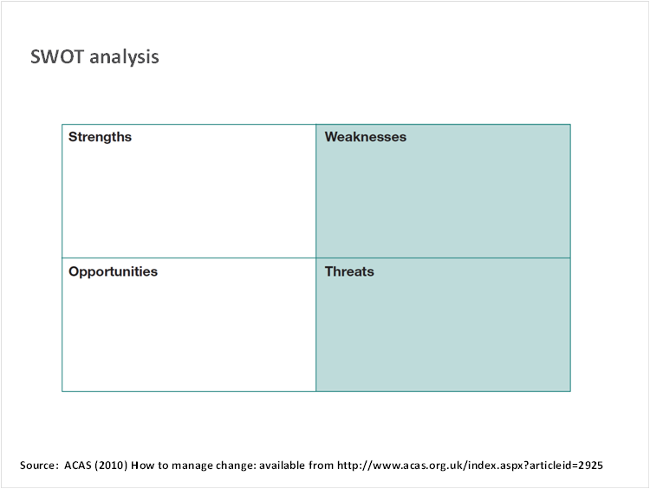

SWOT stands for ‘strengths, weaknesses, opportunities and threats’ and is effective tool for testing out new ideas and problem-solving.
Before you start, be clear about the problem or situation you are going to analyse: this can be very broad – such as wide cultural issues within an organisation – or very specific – such as reducing customer response times.

You may find that many of the strengths and weaknesses relate to internal factors – such as resources, relationships and training – while the opportunities and threats are more likely to be linked to external factors – such as customer demand, market competitors etc.
The key issues that emerge can often be grouped into a few prominent themes. These can be look at more closely in smaller groups.

Source: ACAS (2010) How to manage change: available from http://www.acas.org.uk/index.aspx?articleid=2925

